**1. Write the correct 3rd Person form. Remember the spelling rules!**

eat _________ do ________

study ________ watch ________

drink ________ read ________

make ________ learn ________

tidy __________ play _________

**2. Complete the sentences. Use Present Simple affirmative.**

1. My brother _________ (play) football.

2. We _________ (eat) hamburguers.

3. I _________ (study) French.

4. My friends _________ (listen) to jazz.

5. My mum __________ (like) classical music.

**3. Make the sentences negative.**

1. I eat pizza.

__________________________

2. My brother studies German.

__________________________

3. We play computer games.

__________________________

4. Harry likes sport.

__________________________

5. They drink water.

__________________________

**4. Choose the correct verb form.**

1. We **go/goes** to school by bus.

2. My teacher **speak/speaks** Italian and Japanese.

3. We **don’t/doesn’t** do P.E in the

classroom.

4. My friends don’t **like/likes** art.

5. My mother **teach/teaches** in a primary

school.

6. I don’t **copy/copies** their homework.

7. They **finish/finishes** work at 8.30 in the

evening.

8. We **don’t/doesn’t** think that English is

easy.

**5. Write the questions in the correct order. Then, write short answers.**



**Listen understand tidy go remember start**

**Ask clean fly learn do study**

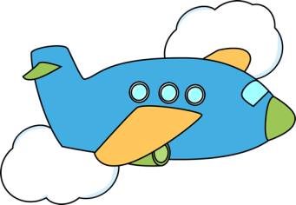

1. your teacher/does/English/speak?

**_____________________________**

2. does/use/a computer/your mother?

_____________________________

3. ask/your teacher/a lot of questions/does?

___________________________________

4. CDs and DVDs/copy/do/you?

__________________________________

5. on Saturday/ to school/go/you/do?

__________________________________

6. do/you/French/understand?

______________________________

7. does/your school/at half past three/ finish?

**_____________________________________**

**6. Write questions.**

1. Bella practises English every day. (her friends?)_____________________________

2. We go to school at nine o’clock. (you?)

____________________________________

3.My father studies French. (study/Italian?)

____________________________________

4. We live near the school. (your teacher?)

____________________________________

5. My sister plays volleyball. (she/football?)

____________________________________

6. They remember their books. (this pens?)

______________________________________

**DDF7. Complete the crossword. Use the –s form of the verbs in the box.**

